User Guide of
Hotel Booking System

Content
1. Develop environment - 2 -
2. Deployment diagram - 2 -
3. Instruction of installation and implementation - 2 -
3.1 To install the JDK software and set JAVA_HOME on a windows system - 2 -
3.2 To install Tomcat and set environment variables - 3 -
3.3 To install Apache Ant and Apache Axis2 - 4 -
3.4 To Install MySQL Server and Workbench - 4 -
3.5 Import database dump - 5 -
3.6 Run Hotel Booking System - 6 -
4. Instruction of system operation - 7 -
4.1 Register - 7 -
4.2 Login - 8 -
4.3 Homepage - 8 -
4.4 Query - 9 -
4.5 Hotel booking - 10 -
4.6 Order management - 11 -

1. Develop environment
- JDK 1.7
- MySQL 5.6
- Tomcat 8
- Apache-ant-1.9.4
- Axis2-1.6.2

2. Deployment diagram

3. Instruction of installation and implementation

3.1 To install the JDK software and set JAVA_HOME on a windows system
1) Install the JDK software.
a. Go to http://java.sun.com/javase/downloads/index.jsp;
b. Select the appropriate JDK software and click Download.
The JDK software is installed on your computer, for example, at C:\Program Files\Java\ jdk1.8.0_31. You can move the JDK software to another location if desired.
2) Set JAVA_HOME:
a. Right click My Computer and select Properties.
b. On the Advanced tab, select Environment Variables, and then edit JAVA_HOME to point to where the JDK software is located, for example, C:\Program Files\Java\ jdk1.8.0_31.

3.2 To install Tomcat and set environment variables
1) Download the .zip file containing the Apache Tomcat Web server, apache-tomcat-8.x.zip from http://tomcat.apache.org/download-80.cgi.
2) To run the Tomcat server, you need to make sure certain environment variables are set correctly. If you use Windows, from the Start menu select Control Panel, then System and, from the “System Properties” dialog, select the “Advanced Tab” and then “Environment Variables”. You will see that there are two windows in the resulting dialog that appears.
a. Create the JRE_HOME environment variable in the “lower” window:
JRE_HOME set to C:\Program~1\Java\jre8
b. Append the following path to the PATH environment variable in the
“lower” window:
PATH add to the end; C:\Servers\tomcat8\bin
c. You will also have to either edit or create the following environment variables in the “upper” window:
CATALINA_HOME set to C:\Servers\tomcat8
CLASSPATH set to C:\Servers\tomcat8\lib\servlet-api
You can now test your setup of Apache Tomcat by opening a console window and typing ‘startup.bat’ at the command line. This should open another console window that indicates Apache Tomcat is running. (If you want to close it just type ‘shutdown.bat’ at the same window you typed startup.)
The final test is opening a web browser and typing in the following:
http://localhost:8080
If all is well this should load the default Apache Tomcat page.

3.3 To install Apache Ant and Apache Axis2
1) Download Apache Ant and Apache Axis2
If you don’t have Apache Ant installed, you need to download and install it from Apache Ant – Binary Distributions (http://ant.apache.org/bindownload.cgi).
Download Axis2 and install it in the “webapps” directory of your Apache Tomcat Web Server. Go to http://axis.apache.org/axis2/java/core/download.cgi, download and unzip the “1.6.2 Release” Binary Distribution zip of Apache Axis2 into any convenient directory of your choice. Go to axis2-1.6.2/webapp directory, and in a command window, run the “ant create.war” command to create the axis2.war and deploy it into the axis2-1.6.2/dist directory. This step is required to create axis2.war that will be deployed to Apache Tomcat and to get the axis2 libraries to be used in projects.
2) Deploy the axis2.war in the Apache Tomcat application server
Next, deploy the axis2.war in the Apache Tomcat application server by copying it in Tomcat webapps directory. You will need to startup the Tomcat server from a command prompt window. Then go to http://localhost:8080/axis2/ and click on Validate link. If the Happy Axis page is coming with GREEN color, then it means that axis2 is successfully deployed. Our system setup is ready now and we can proceed for creating Axis2 web services.
Before we build anything with Axis2, we need to set the AXIS2_HOME, ANT_HOME and JAVA_HOME environment variables. These variables can be set as system variables.

3.4 To Install MySQL Server and Workbench
1) Download MySQL Community Server 5.6 installation file appropriate for the platform in your computer from the webpage http://dev.mysql.com/downloads/mysql/ and install it.
2) Download MySQL Workbench 6.2.5 appropriate for your platform from http://dev.mysql.com/downloads/workbench/ and install it.

3.5 Import database dump
1) Open MySQL Workbench, create account with user name: fit5183, leave password null;
2) Click Administrative Roles, grant DBA role to user fit5183a1;
3) Use user fit5183a1 to create new connection;
4) Import database dump from disk

3.6 Run Hotel Booking System
1) Run HotelBooking2.0
a. Run cmd.exe, then type command: “tnameserv”;
b. Open the folder HotelBooking2.0/dist, click “OneKeyRun.bat” to start the system:
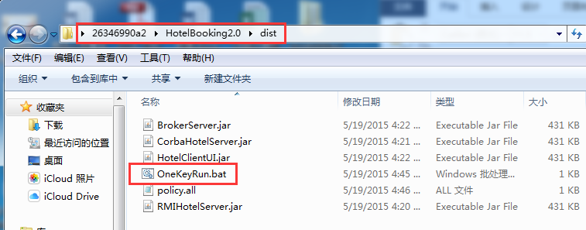
2) Run HotelBooking WebService
a. Cope the “HotelBookingWS.aar” to the “%CATALINA_HOME%\webapps\axis2\WEB-INF\services” directory in your Tomcat server;
b. Start your tomcat server;
c. Open the folder HotelBookingWebService/dist, click “OneKeyRun.bat” to start the system:
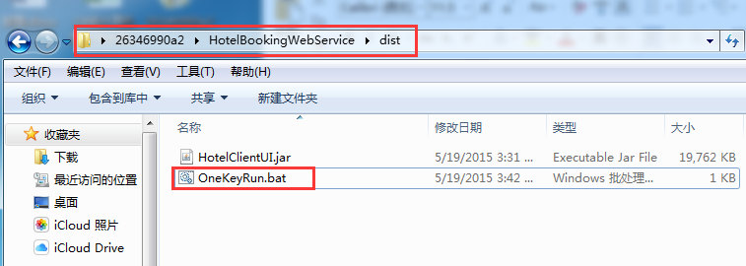

4. Instruction of system operation

4.1 Register
User can follow this instruction to complete register. When there are illegal input, the system will show error information to point it out:

4.2 Login
Input right user ID and password, user can enter homepage of the system. When there are illegal inputs, the system will show error information to point it out:

4.3 Homepage
This is the homepage of the hotel booking system, user can input the corresponding number to use the function they want.

4.4 Query
When user choose to enter query, there will be a list of available cities shown on the screen. User can enter the city ID to query the hotel information in that city. When there are illegal inputs, the system will show error information to point it out:
This is the list of hotel information in selected city:

4.5 Hotel booking
This is the hotel booking page. Follow this instruction, user can make an order of hotel booking. When there are illegal inputs, the system will show error information to point it out, user can retry to make an order:

4.6 Order management
This is order management page. It will list all order information of current user. User can choose to delete order if they want, or just back to the homepage. When there are illegal inputs, the system will show error information to point it out, user can retry to make an order:

